The Title of Paper Times New Roman 14 pt
F.A. Author¹, S.B. Author^{2*}, and T.C. Author³
¹ Affiliation of the A. Author (Department, Institute, City, Country)
² Affiliation of the B. Author (Department, Institute, City, Country
³Affiliation of the C. Author (Department, Institute, City, Country)
*E-mail address of Corresponding Author (clearly indicate who will handle correspondence at all stages of abstract submission and refereeing)

Keywords: Please provide a maximum of 3 keywords, with words separated by comma (1 line only).

This document presents instructions needed to prepare an abstract to be included in the proceedings of the RCM & AMC 2017. Your abstract has to be concise, clear and factual. It should state briefly the purpose of the research, major results that will be presented in the conference and major conclusions. Abbreviations should be avoided, but if essential they must be defined at their first mention in the abstract itself for example scanning electron microscope (SEM); defined; then can be use as abbreviation throughout the abstract. The abstract should be written using Microsoft Word. Please write your abstract in good English (American or British usage is accepted, but not a mixture of these) and must be conform to correct scientific English. Abstract has to be prepared strictly according to the instructions set herein i.e. the margin, font size (Times New Roman, 11 pt) and the spacing (line spacing, single). The abstract must not exceed 1 page (or not more than 200 words) and has to be in one paragraph. You can directly use this template to type your abstract in and upload it in our website. All texts must be set in single column. Please be reminded that your abstract as well as your presentation in the conference must have elements of microscopy. A Graphical Abstract example as shown here is required. Thank you for your participation. Note: all images should not be coloured.
Anodization of Titanium Alloy
Cross section SEM
Surface SEM
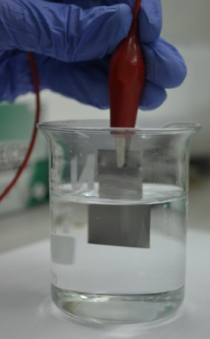
Bottom SEM
TEM of Nanotube
100 nm

